

Unit: ITSU2006R
IT Project Management

Submitted to:

Victorian Institute of Technology

Project Plan Report
Identity and Access Management (IAM) System Deployment for Cybersecurity Enhancement

Document control
Item | Detail
Institution | Victorian Institute of Technology (VIT)
Unit code and name | ITSU2006R
Assessment | Assessment Item 3 – Project Report (Group), 20%
Project chosen | Project 2 – Identity and Access Management (IAM) System Deployment for Cybersecurity Enhancement
Client organisation | Coastal Credit Union Ltd (a fictional APRA-regulated mutual bank used as the case scenario)
Lecturer Name | MD. Hasin Reza Siddiquei
Submission date | 25 oct 2026
GitHub repository | https://github.com/shadmanshakib291105-bit/ccu-iam-project

Group members
Student name | Student ID | Project role | Signature
Md Shadman Shakib | 66310 | Project Manager, Change, Comms and Configuration Lead | Shakib
Md Motiur Rahman Sijan | 66341 | IAM Architect | Sijan
Mahmudul Mahmudul | 68925 | Integration and Test Lead | Mahmudul

Table of Contents
Executive summary
1. Project overview and objectives
2. Project charter and scope statement
3. Work breakdown structure (WBS)
4. Project schedule and Gantt chart
5. Resource allocation and responsibility matrix
6. Risk identification, analysis and mitigation
7. Issue management strategy
8. Change request and change management process
9. Communication management plan
10. Quality management approach
11. Configuration management using GitHub
12. Conclusion
References
Appendix – GitHub evidence

Executive summary
Coastal Credit Union will implement a Cloud Based Identity and Access Management Solution (IAM). This will be done over 32 weeks (from 1 February 2027 to 13 September 2027) with a total budget of $869,000 AUD including 10% contingency. This solution will help combine their three separate user directories as well as manual account management into one central identity. It will provide SSO, phishing resistant MFA, automated joiner/mover/leaver processes and PAM.
The primary driver of this project is regulation. As an APRA regulated entity Coastal Credit Union has to comply with Prudential Standard CPS 234 Information Security (APRA, 2019). An internal audit was performed in 2026 which identified issues such as orphan accounts and shared admin passwords. There was also no MFA in place for accessing their core banking system. This project will help achieve an Essential Eight maturity level of 2 for both of the strategies relating to identity (MFA and limiting administrator privileges) (Essential Eight Maturity Model, ASD, 2023).
The purpose of this document is to identify the details of this project. It will include the scope, WBS with 6 phases and 22 activities, schedule with dependencies and critical path, RACI, risk register with 12 risks, issue and change management, communication plan, quality and configuration management with GitHub. This project will be managed using a hybrid methodology as it will be governed by a predictive phased gate process but will have 2 week sprints within phase 3.

1. Project overview and objectives

1.1 Organisation background
Coastal Credit Union Ltd (CCU) is a customer owned Authorised Deposit-taking Institution operating within New South Wales. They have approximately 95,000 members, 620 employees and run 28 branches. They are regulated by the Australian Prudential Regulation Authority (APRA) and have a core banking solution, Customer Relationship Management (CRM), Microsoft 365, HR system and approximately 40 small business applications. CCU is a fictional company created for this assessment and the numbers represent an example.

1.2 Problem statement
- During their 2026 internal audit, CCU highlighted the following issues around their identity:
- Three separate manual-on-prem Active Directory, the core banking user store and a legacy LDAP for branch systems), each managed by hand.
- 312 active userbelonging to staff who had left; leaver access took an average of 9 business days to remove.
- 41 shared or generic admin accounts with passwords stored in spreadsheets.
- No MFA on core banking &remote aaccess solutions. 34% of service desk tickets were for password resets.
- Access reviews done once a year in spreadsheets, with no evidence trail for auditors.

This gap does not meet CPS 234 requirements (APRA, 2019). This leaves CCU vulnerable to attacks that target credentials such as phishing, password spraying and orphaned accounts.
1.3 Business Case
The IAM platform will reduce risk, increase compliance and reduce cost. In the first year, after being in a steady state it will reduce the amount of tickets raised by approximately 1900 (at a rate of $30 per ticket this will save us around $57,000), reduce manual provisioning by 600 hours. It will also provide audit ready proof that we have complied with CPS 234 and Essential Eight. However, the biggest benefit, reducing the risk of us having a breach due to credentials will not be quantified. This is the main reason why it was approved.

1.4 Project objectives (SMART)
# | Objective | Measure of success | Target date
O1 | Consolidate all workforce identities into one authoritative cloud directory fed by the HR system | 100% of 620 staff and 85 contractor identities sourced from HR; zero orphaned accounts in the go-live audit | 18 Aug 2027
O2 | Enforce phishing-resistant MFA for all staff on remote, cloud and core banking access | 100% MFA enrolment; MFA events centrally logged | 18 Aug 2027
O3 | Automate joiner-mover-leaver provisioning | Leaver access removed within 4 hours (from 9 days); joiner access ready on day 1 for 95% of starters | 18 Aug 2027
O4 | Bring all privileged accounts under a PAM vault | 41 shared admin accounts retired; 100% of admin sessions brokered and recorded | 11 May 2027 (build), 18 Aug 2027 (live)
O5 | Integrate the 12 highest-risk applications with SSO | 12 applications live on SSO, including core banking, CRM and Microsoft 365 | 18 Aug 2027
O6 | Deliver within approved time and cost | Closure by 13 Sep 2027; spend within AUD 869,000 | 13 Sep 2027

2. Project charter and scope statement

2.1 Project charter
Charter item | Detail
Project title | IAM System Deployment for Cybersecurity Enhancement
Project sponsor | Chief Information Officer (CIO), Coastal Credit Union
Project manager | Group member assigned the PM role (see Section 5)
Purpose | Reduce identity-related cyber risk and meet CPS 234 and Essential Eight expectations
Duration | 32 weeks: 1 Feb 2027 to 13 Sep 2027
Approved budget | AUD 869,000 (AUD 790,000 baseline + AUD 79,000 contingency)
Delivery approach | Hybrid: phase gates for governance, two-week sprints within the build phase
Authority | PM may approve changes up to 2 days of schedule and AUD 10,000; larger changes go to the Change Control Board (CCB)
Success criteria | Objectives O1 to O6 met; sponsor sign-off on the closure report

2.2 In scope
Solution selection and implementation:
- Set up Cloud IdP, IGA and PAM solution
- Integration with HR system to provide source of truth for staff and contractors.
- Single Sign On to 12 key applications. Phishing proof MFA implemented for all staff using FIDO2 security keys and number matching authenticator app.
- Role based access control (RBAC) implemented using 14 job families and quarterly automated access reviews.
- PAM vault for all admin/service accounts. Sessions recorded.
- Solution tested (SIT, UAT, Penetration). Training provided. Piloted and rolled out in phases. 28 branches impacted. Legacy LDAP decommissioned.
- Implementation documents, run books and BAU support model provided.

2.3 Out of scope

Customer (member) identification for internet banking. This will be addressed separately as part of the CIAM programme.

Integration of the remaining 28 low risk applications as part of a Phase 2 project.

Replacement of core banking platform or HR system.

Physical access control (swipe cards).

Changes to network segmentation and endpoint security (excluding any changes required for IAM agents)

2.4 Major deliverables
ID | Deliverable | Acceptance criteria
D1 | Approved project charter and management plans | Signed by sponsor
D2 | Current-state audit and CPS 234 gap analysis report | Reviewed by CISO and internal audit
D3 | Vendor selection report and signed contract | Procurement and legal approval
D4 | Solution architecture and RBAC role model | Approved at design gate (M1) by Architecture Review Board
D5 | Configured IAM platform (IdP, IGA, PAM) in production | Passes SIT, UAT and penetration test with no open critical or high findings
D6 | 12 applications integrated with SSO and MFA | Each passes its UAT script
D7 | Trained users and support staff | 95% of staff complete training module; service desk runbook signed off
D8 | Legacy LDAP decommissioned | Server shut down; no authentication traffic for 10 days
D9 | BAU handover pack and closure report | Signed by operations manager and sponsor

2.5 Constraints

The budget is limited to a maximum of AUD 869,000 this financial year.

No changes to production can be made during the end of financial year freeze period between 21 June and 2 July 2027. Testing can only take place in the test environment and cut over to production will commence with pilot from 8 July.

Only core banking changes can be implemented during the core maintenance period (Sunday 10pm-4am).

The solution must ensure that identity data is stored in Australian data centres

.2.6 Assumptions

Data accuracy within the HR system will be at least 95% once one off clean up activity has been completed.

The vendor selected will have support for SAML 2.0 and OpenID Connect for the priority 12 applications.

Key stakeholder time from clients will be available for the CISO, HR systems lead and service desk manager for at least 20%.

Two week sprints will be supported during phase 3 through integration partner with certified engineers.

2.7 Key stakeholders
Stakeholder | Interest | Influence | Engagement strategy
Board and Risk Committee | CPS 234 accountability | High | Monthly status via CIO; risk register highlights
CIO (sponsor) | Delivery on time and budget | High | Weekly one-to-one; chairs steering committee
CISO | Security outcomes, audit findings closed | High | Member of steering committee and CCB
HR manager | Accurate staff data, onboarding speed | Medium | Workshops in design; UAT participation
Branch managers | Minimal disruption to member service | Medium | Branch briefings, rollout schedule, floor-walkers
Staff (620) | Easy login, no lockouts | Low | Training, intranet updates, help guides
Service desk | Support load during rollout | Medium | Runbooks, early training, hypercare roster
IAM vendor and integration partner | Contract delivery | Medium | Weekly technical stand-up; contract milestones
Internal audit and APRA | Evidence of controls | High | Audit trail, test reports, closure evidence pack

2.8 Milestones
Milestone | Date | Gate criteria
Charter approved | 5 Feb 2027 | Sponsor signature
M1 – Design approval gate | 12 Apr 2027 | Architecture and role model approved; vendor contracted
Build complete | 8 Jun 2027 | All 12 integrations configured in test
M2 – Go-live approval (CAB) | 7 Jul 2027 | No open critical/high defects or pen-test findings; UAT signed
Rollout complete | 18 Aug 2027 | All 28 branches live
M3 – Project closed | 13 Sep 2027 | Closure report signed

2.9 Budget estimate
Cost item | AUD
IAM platform licences, year 1 (IdP and MFA, IGA, PAM) | 300,000
Integration partner services | 210,000
Internal staff backfill | 170,000
FIDO2 security keys (600 at AUD 80) | 48,000
Independent penetration test | 35,000
Training and change management | 27,000
Baseline total | 790,000
Contingency reserve (10%) | 79,000
Total approved budget | 869,000

3. Work breakdown structure (WBS)
The scope is decomposed into 6 deliverable-oriented phases and 22 work packages, with three gate milestones. Project management (status reporting, risk, change and quality control) runs across all phases and is costed within internal staff backfill.
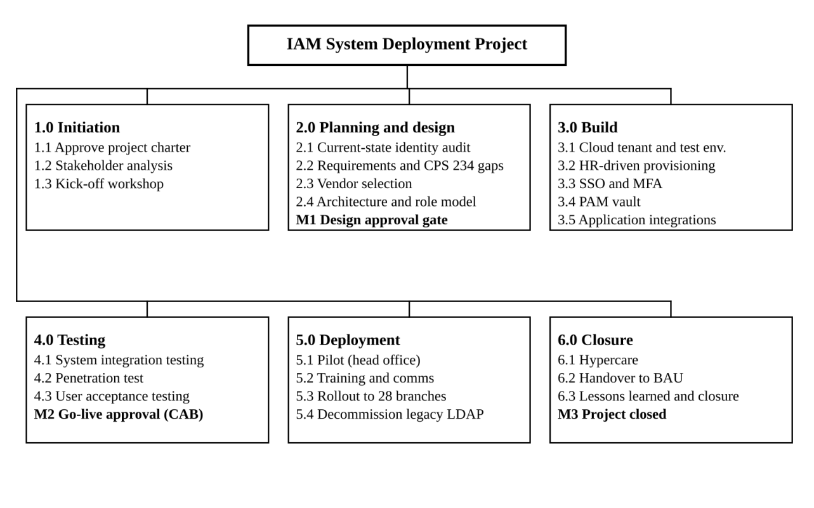
Figure 1: Work breakdown structure (WBS) of the IAM project

3.1 WBS dictionary
WBS ID | Work package | Description and output | Owner
1.1 | Approve project charter | Charter, budget and governance approved by the sponsor | Project Manager
1.2 | Stakeholder analysis | Stakeholder register and engagement plan | Project Manager
1.3 | Kick-off workshop | Shared plan, roles and ways of working agreed | Project Manager
2.1 | Current-state identity audit | Inventory of all accounts, directories and applications; orphaned and privileged accounts listed | IAM Architect
2.2 | Requirements and CPS 234 gap analysis | Functional and security requirements; gap report against CPS 234 and Essential Eight | Security Analyst
2.3 | Vendor evaluation and selection | Weighted scoring of 3 shortlisted vendors, proof of concept, contract | IAM Architect
2.4 | Solution architecture and role model | High-level and detailed design; RBAC model for 14 job families | IAM Architect
3.1 | Provision cloud tenant and test environment | Production and test tenants in Australian region; baseline hardening | Integration Lead
3.2 | HR-driven provisioning | Joiner-mover-leaver workflows from the HR system to the directory | Integration Lead
3.3 | SSO and MFA | SSO policies, FIDO2 and authenticator app enrolment, conditional access | IAM Architect
3.4 | PAM vault | Vault deployed; 41 shared admin accounts replaced with named, brokered access | Security Analyst
3.5 | Application integrations | 12 priority applications connected via SAML or OIDC | Integration Lead
4.1 | System integration testing | End-to-end test of all integrations and workflows | Test Lead
4.2 | Penetration test and security review | Independent test; findings remediated or risk-accepted | Security Analyst
4.3 | User acceptance testing | Business users sign off scripted scenarios | Test Lead
5.1 | Pilot rollout | 150 head office users live for 2 weeks; feedback captured | Change and Comms Lead
5.2 | Training and communications | E-learning module, quick guides, branch briefings | Change and Comms Lead
5.3 | Phased rollout | 28 branches in 3 waves of about 9 branches | Project Manager
5.4 | Decommission legacy authentication | Legacy LDAP retired after 10 days with no traffic | Integration Lead
6.1 | Hypercare | Two weeks of enhanced support and daily defect triage | Integration Lead
6.2 | Handover to BAU | Runbooks, support model and knowledge transfer accepted by operations | Project Manager
6.3 | Lessons learned and closure | Lessons learned log, benefits baseline and closure report | Project Manager

4. Project schedule and Gantt chart
The project will run for 157 working days between 1 Feb 2027 (Mon) and 13 Sep 2027 (Mon). There are 18 activities/milestones out of 25 that lie along the critical path. The duration is calculated in working days (Mon-Fri) excluding Public Holidays in NSW (Good Friday, Easter Monday, Anzac Day and King's Birthday). All relationships are finish to start.
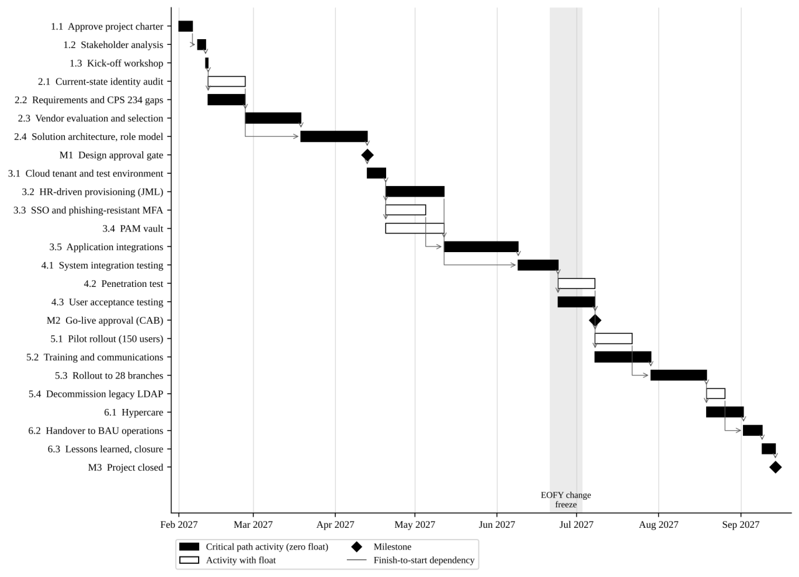
Figure 2: Gantt chart showing activities, dependencies and the critical path (1 February to 13 September 2027)

4.1 Activity list and dependencies
ID | Activity | Duration (days) | Predecessors | Start | Finish | Total float (days)
1.1 | Approve project charter | 5 | – | 1 Feb | 5 Feb | 0
1.2 | Stakeholder analysis and register | 3 | 1.1 | 8 Feb | 10 Feb | 0
1.3 | Kick-off workshop | 1 | 1.2 | 11 Feb | 11 Feb | 0
2.1 | Current-state identity audit | 10 | 1.3 | 12 Feb | 25 Feb | 15
2.2 | Requirements and CPS 234 gap analysis | 10 | 1.3 | 12 Feb | 25 Feb | 0
2.3 | Vendor evaluation and selection | 15 | 2.2 | 26 Feb | 18 Mar | 0
2.4 | Solution architecture and role model | 15 | 2.1, 2.3 | 19 Mar | 12 Apr | 0
M1 | Design approval gate | 0 | 2.4 | 12 Apr | 12 Apr | 0
3.1 | Provision cloud tenant and test environment | 5 | M1 | 13 Apr | 19 Apr | 0
3.2 | HR-driven provisioning (joiner-mover-leaver) | 15 | 3.1 | 20 Apr | 11 May | 0
3.3 | SSO and phishing-resistant MFA | 10 | 3.1 | 20 Apr | 4 May | 5
3.4 | PAM vault | 15 | 3.1 | 20 Apr | 11 May | 20
3.5 | Application integrations | 20 | 3.2, 3.3 | 12 May | 8 Jun | 0
4.1 | System integration testing | 10 | 3.4, 3.5 | 9 Jun | 23 Jun | 0
4.2 | Penetration test and security review | 10 | 4.1 | 24 Jun | 7 Jul | 5
4.3 | User acceptance testing | 10 | 4.1 | 24 Jun | 7 Jul | 0
M2 | Go-live approval (CAB) | 0 | 4.2, 4.3 | 7 Jul | 7 Jul | 5
5.1 | Pilot rollout (head office, 150 users) | 10 | M2 | 8 Jul | 21 Jul | 5
5.2 | Training and communications | 15 | 4.3 | 8 Jul | 28 Jul | 0
5.3 | Phased rollout to 28 branches | 15 | 5.1, 5.2 | 29 Jul | 18 Aug | 0
5.4 | Decommission legacy authentication | 5 | 5.3 | 19 Aug | 25 Aug | 5
6.1 | Hypercare | 10 | 5.3 | 19 Aug | 1 Sep | 0
6.2 | Handover to BAU operations | 5 | 6.1, 5.4 | 2 Sep | 8 Sep | 0
6.3 | Lessons learned and closure report | 3 | 6.2 | 9 Sep | 13 Sep | 0
M3 | Project closed | 0 | 6.3 | 13 Sep | 13 Sep | 0

4.2 Critical path
The critical path is 1.1 → 1.2 → 1.3 → 2.2 → 2.3 → 2.4 → M1 → 3.1 → 3.2 → 3.5 → 4.1 → 4.3 → 5.2 → 5.3 → 6.1 → 6.2 → 6.3 → M3. Any delay to these activities moves the closure date day for day. Float was calculated with a forward and backward pass using the critical path method (Schwalbe, 2019).

There are 3 schedule decisions that ensure the critical path:

Vendor selection (2.3) does not depend on the requirement but on the requirements. This means the audit (2.1) can happen in parallel with 15 days of float.

HR driven provisioning (3.2) is a critical path activity as clean identities are needed for application integrations. This means we staff this first in Sprint 1.

Training (5.2) can start as soon as UAT is complete meaning it will happen in parallel to the pilot. As such rollout to the branch will be dependent on whichever is complete last.

Scheduling is managed using GitHub Projects (roadmap view). Microsoft Project is used to report to the steering committee. The baseline is set at the M1 gate and any variances are reported on a weekly basis.

5. Resource allocation and responsibility matrix
The project is delivered by a core team of 6 roles (the four student group members take the first four), supported by client staff, the vendor and an integration partner. Allocation is highest in the build and test phases, from April to July 2027.

5.1 Project roles and allocation
Role | Filled by | Key responsibilities | Allocation
Project Manager (PM) | Group member 1 | Plan, schedule, budget, risks, issues, change control, reporting | 100%, whole project
IAM Architect | Group member 2 | Architecture, role model, SSO and MFA design, vendor evaluation | 100%, Feb to Jul; 50% Aug to Sep
Integration and Test Lead | Group member 3 | Provisioning, application integrations, SIT and UAT coordination, cut-over | 100%, Apr to Sep
Change, Comms and Configuration Lead | Group member 4 | Training, communications, GitHub repository, document control | 50% Feb to Jun; 100% Jul to Sep
Security Analyst (client) | CCU cyber team | CPS 234 gap analysis, PAM vault, pen test coordination | 60%, Feb to Jul
Integration engineers (2) | Integration partner | Configuration and connector build in Phase 3 sprints | 100%, Apr to Jul
Project sponsor | CIO | Funding, gate approvals, escalations | About 2 hours per week
HR systems lead | CCU HR | HR data clean-up, provisioning workflow design, UAT | 20%, Feb to Jun
Service desk manager | CCU IT operations | Support model, runbooks, hypercare roster | 20% Jun to Sep

5.2 Other resources

Cloud IAM tenancy (production + test) located within Australian region, licensed to support 750 identities.

600 FIDO2 tokens (500 staff + 100 spares/admin). Remaining staff use authenticator app.

External CREST accredited penetration testing company (10 days).

GitHub Team for repository management. Projects board, issues and pull requests.

Training room available at Head Office and e-learning module on current learning platform.

5.3 RACI matrix
R = Responsible (does the work), A = Accountable (one per row, signs off), C = Consulted, I = Informed. Column headings are short forms: Architect = IAM Architect, Test Lead = Integration and Test Lead, Config Lead = Change, Comms and Config Lead, Security = Security Analyst, HR = HR systems lead, Desk = Service desk manager.
Work package | Sponsor | PM | Architect | Test Lead | Config Lead | Security | HR | Desk
1.1 Project charter | A | R | C | C | C | C | I | I
1.2 Stakeholder analysis | I | A/R | C | C | R | C | C | C
2.1 Identity audit | I | A | R | C | I | R | C | C
2.2 Requirements and CPS 234 gaps | I | A | C | C | I | R | C | C
2.3 Vendor selection | A | R | R | C | I | C | I | I
2.4 Architecture and role model | I | C | A/R | C | I | C | C | I
3.2 HR-driven provisioning | I | C | C | A/R | I | I | R | I
3.3 SSO and MFA | I | C | A/R | R | I | C | I | C
3.4 PAM vault | I | C | C | C | I | A/R | I | I
3.5 Application integrations | I | C | C | A/R | I | C | I | I
4.1–4.3 Testing | I | A | C | R | I | R | R | C
M2 Go-live approval | A | R | C | C | C | C | I | C
5.1–5.3 Pilot, training, rollout | I | A | C | R | R | I | I | R
5.4 Legacy shutdown | I | A | C | R | I | C | I | I
6.1–6.2 Hypercare and handover | I | A | C | R | C | I | I | R
6.3 Closure report | A | R | C | C | C | C | I | I
GitHub configuration management | I | A | C | C | R | I | I | I

5.4 Resource levelling

The IAM Architect is over-loaded during Sprint 1 (20 April – 4 May) due to the overlapping activities within SSO and MFA (3.3) and Provisioning Support Design. The PAM Vault (3.4) task has 20 days of float, therefore the Security Analyst will lead on this task with the architect providing consultancy support. The SSO task will consume 2 of the 5 float days if necessary. No Critical Path activities are being moved.

6. Risk Identification, Analysis & Mitigation

There were 12 risks identified. Of which 9 were High risk. The most significant risks were poor data quality in HR (R2) and integrating with core banking (R1). These risks are managed using the enterprise risk management framework provided by CCU. This follows the ISO 31000 standard (ISO, 2018).6.1 Risk management process
- Identify – risk workshops at kick-off and at each phase gate, plus any team member raising a risk as a GitHub issue labelled risk.
- Analyse – score likelihood and impact from 1 to 5; score = L × I. Impact considers schedule, cost, security and member service.
- Evaluate – Low (1–4) accept and monitor; Medium (5–9) mitigate within the team; High (10–16) mitigation plan with a named owner, reported to steering committee; Extreme (20–25) escalate to sponsor within 24 hours.
- Respond – choose a strategy: avoid, mitigate, transfer or accept; assign an owner and a trigger.
- Monitor – the register is reviewed weekly by the PM and monthly by the steering committee; closed risks are kept for lessons learned.
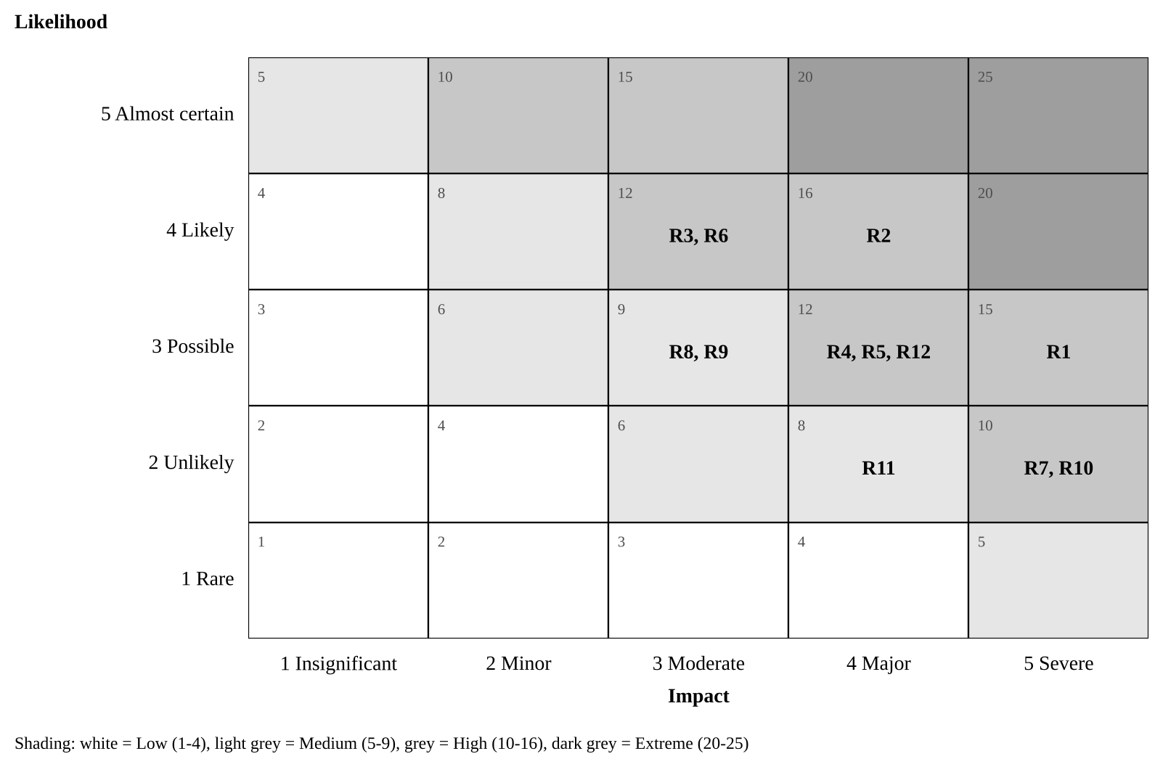
Figure 3: Risk matrix showing inherent risk of the 12 identified risks

6.2 Risk register
ID | Risk (cause → effect) | Score (L × I) | Strategy | Mitigation, contingency and trigger | Owner
R1 | Core banking supports only legacy authentication → SSO cannot be applied to the highest-risk system | 3 × 5 = 15 High | Mitigate | Core banking SSO must be shown in the vendor proof of concept (2.3); fallback is an access gateway with MFA in front of core banking. Trigger: PoC fails the core banking scenario. | IAM Architect
R2 | HR records are inaccurate or incomplete → wrong access granted or leavers missed | 4 × 4 = 16 High | Mitigate | Data clean-up during audit (2.1); run provisioning in report-only mode for 2 weeks and reconcile daily before enforcing. Trigger: Reconciliation error rate above 2%. | HR systems lead
R3 | Staff find MFA unfamiliar → lockouts and slower member service in branches | 4 × 3 = 12 High | Mitigate | Pilot first, 15-minute e-learning, branch floor-walkers on go-live days, self-service recovery. Trigger: Lockout tickets above 30 per day. | Change, Comms and Config Lead
R4 | Key client staff are pulled into BAU work → design and testing delays | 3 × 4 = 12 High | Mitigate | Backfill budget (AUD 170,000); named deputies; time commitments agreed in charter. Trigger: Two missed workshops in a row. | PM
R5 | Pen test finds critical issues late → go-live postponed | 3 × 4 = 12 High | Mitigate | Security design review at M1; configuration scanning during build; 5 days float on 4.2. Trigger: Any critical finding open at 30 June. | Security Analyst
R6 | Business units request extra applications → scope creep | 4 × 3 = 12 High | Avoid | Strict change control (Section 8); extra applications go to a Phase 2 backlog. Trigger: Change requests that add applications. | PM
R7 | Break-glass or admin access lost during PAM cut-over → systems cannot be administered | 2 × 5 = 10 High | Mitigate | Two sealed break-glass accounts tested before cut-over; staged onboarding by system; rollback plan. Trigger: Failed break-glass test. | Security Analyst
R8 | Licence procurement or vendor resourcing slips → build starts late | 3 × 3 = 9 Medium | Transfer | Contract with delivery milestones and penalties; purchase order raised during 2.3. Trigger: Contract not signed by 18 Mar. | PM
R9 | Integrations need more effort than estimated → cost overrun | 3 × 3 = 9 Medium | Transfer, mitigate | Fixed-price statement of work for the 12 integrations; 10% contingency held by sponsor. Trigger: Earned value CPI below 0.95. | PM
R10 | Cloud IdP outage → staff cannot log in to any system | 2 × 5 = 10 High | Mitigate | 99.9% availability SLA; cached credentials and offline MFA for core banking; outage runbook in BCP (APRA, 2023). Trigger: Vendor incident alert. | Integration and Test Lead
R11 | Identity data stored offshore or over-collected → privacy or contractual breach | 2 × 4 = 8 Medium | Avoid | Australian region written into contract; privacy impact assessment before build. Trigger: PIA raises a high finding. | Security Analyst
R12 | Attackers send repeated MFA prompts during rollout → account takeover | 3 × 4 = 12 High | Mitigate | Number matching and FIDO2 keys for admins; rate limiting; awareness message in every rollout email. Trigger: Unusual MFA denial spikes. | Security Analyst
After mitigation, every High risk is expected to fall to Medium or Low; residual scores are re-assessed at each gate and recorded in the register on GitHub.

7. Issue management strategy
Issues are problems that are currently impacting the project. All issues are created in GitHub as an issue with a priority and owner within 1 business day. They are tracked on the project board until they are closed.

7.1 Issue lifecycle
- Raise: Any member of the team will raise an issue using the issue report template to describe the problem, impact, when it was identified and which work packages were affected.
- Triage: New issues are reviewed by the PM on a daily basis. They will prioritise, assign owners and identify a resolution date.
- Analyse: Owner will analyse the issue to identify the root cause and possible solutions. This will be documented in the issue thread.
- Resolve: The solution will be implemented. If the corrective action impacts scope/schedule/cost, then the owner will raise a change request (see section 8) and link this into the issue.
- Verify & Close: The raiser will confirm the issue has been resolved. PM will close the issue and document any lessons learned..

7.2 Priority and escalation
Priority | Definition | Target resolution | Escalation path
P1 Critical | Blocks a critical-path activity, causes a security exposure or affects member service | 1 business day | PM informs sponsor and CISO immediately
P2 High | Delays a non-critical activity by more than its float, or affects a milestone | 3 business days | PM reports at weekly steering update
P3 Medium | Workaround exists; no milestone impact | 10 business days | Managed within the team
P4 Low | Minor or cosmetic | Next sprint or backlog | Managed within the team
An unresolved issue escalates one level when it passes its target date. Issues that turn out to be recurring are added to the risk register as risks for the rest of the project.

7.3 Issue log (GitHub)

Issue Log – This is used in GitHub by using the filtered view label:issue. This provides information such as Issue ID, Title, Priority, Owner, Status (Open, In progress, Blocked, Resolved, Closed), Date Raised, Target Date and Change Request. The PM will provide an overview of how many P1/P2 Issues are currently open and the average age of open Issues. Issue Log template can be found in appendix B.

7.4 Example issues
ID | Issue | Priority | Owner | Action
I-01 | HR system API rate limit stops full identity sync in test | P2 | Integration and Test Lead | Vendor raises limit; sync batched overnight
I-02 | Two branches have no FIDO2-compatible USB ports on teller PCs | P2 | Change, Comms and Config Lead | Those tellers use the authenticator app; PCs listed for refresh
I-03 | UAT testers from lending unavailable in week 1 of UAT | P3 | PM | Lending scripts moved to week 2; within float

8. Change request and change management process
No changes are made to the approved scope, schedule baseline, budget, or design. Any changes must be approved via approved change requests (CR). Minor changes (2 working days or less schedule impact to non-critical activities, or AUD 10,000) can be approved by the PM. Anything larger, or relating to critical path, security controls or milestones will be escalated to the Change Control Board (CCB).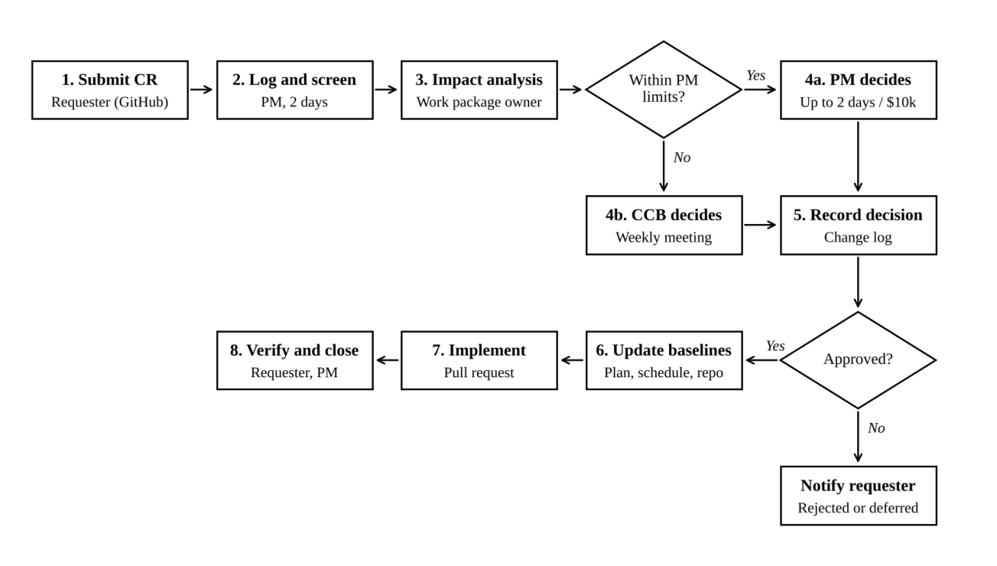
Figure 4: Change request process flow

8.1 Process steps
1.Submit – The change requestor will create a GitHub issue using the Change request template (Appendix A). They will include what, why, the urgency and benefit of the change.
2.Log and Screen – Within 2 business days the PM will assign a CR number, ensure that there is everything required and any duplicate or out of scope ideas rejected. These will be placed into the Phase 2 backlog.
3.Impact analysis – The work package owner will carry out an impact analysis looking at how the change will affect the scope, schedule (including critical path and float), cost, quality, risk, security and compliance. This will be completed within 5 business days.
4.Decide – Any changes that fall under delegated authority will be decided by the PM. If they do not then they will be passed onto the weekly CCB. This can result in approval, rejection, deferring or asking for further information.
5.Record – The decision will be recorded in the CR issue along with any conditions attached to it and who approved it.
6.Baseline Updates – The PM will update the schedule, budget, risk register and relevant documents if the CR has been approved. All document changes are done via a pull request to keep a historical record in the repo.
7.Implement and Verify – The change will be implemented and tested. It will be confirmed by the change requestor that the change met their needs and closed by the PM.
8.Communicate – Any changes that have been approved will be summarised in the weekly status report. Any rejected or deferred changes will be explained to the change requestor.
8.2 Change Control Board
Member | Role on CCB
CIO (sponsor) | Chair; final decision on budget and milestone changes
CISO | Approves any change to security controls or risk acceptance
Project Manager | Presents impact analysis; secretary
IAM Architect | Technical and design impact
Operations manager | BAU and service impact
The CCB will meet every week as part of the project (on a Wednesday for 30 mins) and can be called within 24 hrs if there are any urgent changes to approve. The minimum number of people required for the meeting is the Chair, CISO and PM. Any changes to production that have been approved by the CCB still need to go through the CCU IT Change Advisory Board (CAB). This means that there is a link between project change control and operational change control.

8.3 Change classification
Class | Example | Approver | Target decision time
Minor | Reword a training guide; move a non-critical task within its float | PM | 2 business days
Major | Add an application to SSO scope; use contingency; change a milestone | CCB | Next weekly CCB
Emergency | Urgent fix to a security weakness found in testing | CCB chair and CISO | 24 hours, ratified at next CCB

8.4 Organisational change management

Due to the different login processes, the change management for this will be handled via the ADKAR model (Hiatt, 2006). This includes: Awareness (the message from the CEO and articles on the Intranet from May); Desire (stories about why MFA is protecting our members); Knowledge (via e-learning and quick reference guides); Ability (Pilots, floor walkers and a practice environment); and Reinforcement (Dashboard showing how many people have signed up to MFA per branch and early adopter recognition).

9. Communication Management Plan

Each group of stakeholders will be provided with specific information at set intervals. All communication will be done via one owned channel. Project artefacts will be stored using GitHub as the single source of truth. There will be discussions and meetings via Microsoft Teams, but emails will only be sent for official approvals and organisation wide communications.

9.1 Communication matrix
Item | Audience | Purpose | Frequency | Channel | Owner
Daily stand-up | Core team, integration partner | Progress, plans, blockers | Daily, 15 min (build and test phases) | Teams call; GitHub board | PM
Weekly status report | Sponsor, CISO, steering committee | Schedule and cost variance, top risks, P1/P2 issues, decisions needed | Weekly, Friday | Email (PDF from GitHub wiki) | PM
Steering committee | CIO, CISO, CFO, HR manager, PM | Gate decisions, escalations, budget | Monthly and at each gate | Meeting with minutes | PM
Change Control Board | CCB members | Decide change requests | Weekly, Wednesday | Teams meeting; CR issues | PM
Sprint review and demo | Core team, business representatives | Show completed build items, gather feedback | Every 2 weeks (Phase 3) | Teams demo | IAM Architect
Board risk update | Board Risk Committee | CPS 234 progress and residual risk | Monthly | Paper via CIO | CIO with PM input
Staff updates | All 620 staff | What is changing, when and what to do | Fortnightly from May; weekly during rollout | Intranet, email, branch huddles | Change, Comms and Config Lead
Branch rollout pack | Branch managers | Wave dates, checklist, support contacts | 2 weeks before each wave | Email and briefing call | Change, Comms and Config Lead
Service desk briefing | Service desk | Known issues, runbooks, escalation | Before pilot and each wave; daily in hypercare | Teams; knowledge base | Integration and Test Lead
Vendor stand-up | Vendor, integration partner, IAM Architect | Technical progress and defects | Weekly | Teams | IAM Architect
Lessons learned | All stakeholders | Improve future projects | At each gate and at closure | Workshop; GitHub wiki | PM

9.2 Escalation path
The information flows from team member to work package owner then to Project Manager, Sponsor (CIO) and steering committee. However any security issues must be reported directly to the CISO following the incident management plan within CCU. This includes reporting to APRA within 72 hours of a material information security incident within the CPS 234 requirement (APRA, 2019).

9.3 Communication principles
- Single message source – All communication to staff is approved by the Change, Comms and Config Lead and HR manager.
- No jargon – Messages will be written in clear language. For example, ‘security key’ rather than ‘FIDO2 authoriser’.
- All meeting notes and decisions are recorded in the GitHub wiki within 24 hrs (see template in appendix C).
- All status reports will follow the same definition of RAG status (Red, Amber, Green) to ensure consistent trends.

10. Quality management approach
Quality is defined as meeting the acceptance criteria in Section 2.4 and the security standards CCU is held to. The approach follows the plan–do–check–act cycle: quality planning sets standards and metrics, quality assurance checks that the process is followed, and quality control tests the deliverables.

10.1 Quality standards applied
- APRA CPS 234-information security roles, controls, testing and incident notification.
- ACSC Essential Eight includes multi factor authentication and limiting admin rights to maturity level 2.
- Authentication assurance according to NIST SP 800-63B-4. Admins and core banking users will be at AAL3 (Phishing resistant hardware bound keys). All other staff will be at AAL2. (Temoshok et al., 2025)
- Access controls per ISO/IEC 27001:2022 (Annex A 5.15-5.18 and 8.2-8.5). (ISO & IEC, 2022)
- Project management practices from the PMBOK Guide to manage the scope, timeline, risks and quality of the project. (PMI, 2025)

10.2 Quality metrics
Metric | Target | Measured by | When
Requirements traced to test cases | 100% | Traceability matrix in GitHub | Before SIT
SIT test pass rate | 95% first run; 100% before UAT exit | Test management log | 4.1
Open defects at go-live | 0 critical, 0 high, ≤ 10 medium with workarounds | GitHub issues label:defect | M2
Penetration test findings | 0 critical or high unresolved | Pen test report | 4.2
SSO login success rate in pilot | ≥ 99% | IdP sign-in logs | 5.1
Leaver de-provisioning time | ≤ 4 hours for 100% of leavers | IGA audit report | Weekly from 5.3
MFA enrolment | 100% of staff | IdP dashboard | 18 Aug 2027
User satisfaction after rollout | ≥ 4 out of 5 | Pulse survey | 6.1
Documents peer-reviewed before approval | 100% | Pull request approvals | Ongoing

10.3 Quality assurance activities
- All Plans and Design documents peer reviewed via GitHub pull request process. Minimum 1 reviewer required (non-author).
- Design gate at M1 includes Architecture Review Board.
- Security review will be performed by CCU internal audit team. All CPS 234 controls will be reviewed to ensure evidence is provided. This will be completed prior to going live.
- PM will perform a process audit. Are risks, issues and CRs being recorded and up to date?
- Lessons learned captured at all gates.

10.4 Quality control activities
Test level | What is tested | Who | Exit criteria
Unit and configuration checks | Each policy, connector and workflow as built | Integration engineers | Configuration checklist complete; automated policy checks pass
System integration testing (SIT) | End-to-end flows: HR joiner to app access, mover, leaver, SSO, MFA, PAM checkout | Integration and Test Lead | 100% of SIT cases passed or deferred by CCB
Penetration test | IdP, PAM, admin interfaces, MFA bypass attempts | CREST-accredited third party | No critical or high findings open
User acceptance testing (UAT) | 45 business scenarios across 6 departments | Business testers, Test Lead | Signed UAT certificate from each department head
Operational acceptance | Backup, monitoring, break-glass, runbooks | Service desk and operations | Operations manager sign-off
Defects are logged as GitHub issues with a severity label and linked to the failed test case. A defect review is held daily during SIT and UAT.

11. Configuration management using GitHub

All of our project documentation, including our IAM infrastructure as code and tracking tools are stored in one private GitHub repo. We make use of Git to keep track of all versioning. We also ensure we have branch protection to only allow changes that have been reviewed into our approved baseline. Tags are applied to denote an approved baseline so we can always provide what has been approved and when to auditors.

11.1 Why GitHub
GitHub has been selected as the source control tool as it offers several features including: Issues (risk/issue/defect/change log), Projects (Kanban board/roadmap view of the schedule), Pull requests (peer review and proof of approval), Wiki (minutes/status reports) and Actions (automated testing) all in one place. The free plan allows for private repositories with other collaborators meaning it fits the requirements of our group. This has been compared to other tools such as GitLab and Bitbucket.

11.2 Configuration items (CIs)
Configuration item | Location in repository | Baseline at | Change approval
Project charter and this plan | /docs/plan/ | Charter approval (v1.0) | CCB
Requirements and traceability matrix | /docs/requirements/ | M1 | CCB
Solution architecture and RBAC role model | /docs/design/ | M1 | CCB with Architecture Review Board
Schedule and budget | /docs/plan/schedule/ and GitHub Projects | M1 | CCB
Risk, issue and change registers | GitHub Issues with labels risk, issue, change-request | Live | PM
IAM policies and connector configuration (as code) | /config/ (Terraform and JSON exports) | M2 | CCB and CAB
Test plans, scripts and results | /tests/ | M2 | Test Lead
Training materials and runbooks | /docs/training/, /docs/runbooks/ | M2 | Change Lead and Ops manager
Secrets (API keys, passwords, certificates) are never committed. They are stored in the PAM vault; a .gitignore and GitHub secret scanning with push protection block accidental commits.

11.3 Repository structure
The repository is organised into the following folders:
Folder or file | What it contains
README.md | Purpose of the repository, how to contribute, contacts
CONTRIBUTING.md | Branching, commit and review rules
CHANGELOG.md | Summary of each tagged baseline
.github/CODEOWNERS | Who must review which folders
.github/ISSUE_TEMPLATE/ | Forms for risks, issues, change requests and defects
.github/pull_request_template.md | Checklist shown on every pull request
.github/workflows/docs-check.yml | Automatic markdown and link checks
docs/ | Sub-folders: plan, requirements, design, training, runbooks, meetings
config/ | IAM policy and connector configuration exports
tests/ | SIT and UAT test scripts and results

11.4 Branching and review workflow
The team uses GitHub Flow, a simple trunk-based model suited to a small team:
1. Main contains the version of each item approved and is protected. No direct pushes, 1+ approvals, required status checks and linear history (GitHub, n.d.)
2. Each piece of work has a feature branch with a descriptive name indicating what the branch is for. Branch names will follow this format: docs/42-risk-register-update, config/57-mfa-policy, cr/63-add-payroll-app
3. Commit messages are descriptive and include reference to the issue. Example: Update R2 mitigation after data audit (#42)
4. A pull request is raised early. This will be created as a draft. The correct reviewer is requested using the CODEOWNERS file. For example, the PM will be requested for /docs/plan/, the IAM Architect for /docs/design/ and /config/.
5. A GitHub Actions check is run on all pull requests. The PR can only be merged once all checks have passed and the reviewer has approved. This will close the linked issue.
6. At each gate, the PM will create an annotated tag. A GitHub Release is created with the following tags: v1.0-charter, v2.0-design-baseline, v3.0-go-live, v4.0-closure. Notes will be added to the CHANGELOG.md.The basic Git commands used by the team are shown below:
git checkout main && git pull
git checkout -b docs/42-risk-register-update
# edit files
git add docs/plan/risk-register.md
git commit -m “Update R2 mitigation after data audit (#42)”
git push -u origin docs/42-risk-register-update
# open pull request on GitHub, request review, merge after approval
git tag -a v2.0-design-baseline -m “Design baseline approved at M1, 12 Apr 2027”
git push origin v2.0-design-baseline

11.5 Configuration status accounting and audit
- Status accounting – the GitHub Projects board shows every work item as Backlog, In progress, In review or Done, and the Insights tab shows commit and PR activity by member, which also serves as evidence of each member’s contribution to this assessment.
- Configuration audit – before each gate the Change, Comms and Config Lead checks that every CI in Section 11.2 is at its expected version, that no unmerged branches touch baselined items and that the release notes match the CCB decisions.
- Traceability – each change request issue links to its pull request, commits and tag, so any change can be traced from request to approved baseline.
- Access control – repository access uses CCU’s SSO and MFA once live; members have Write access, the PM and Config Lead have Maintain, and branch protection rules apply to administrators too.
Screenshots of the repository, commit history, issue log, pull request, project board and collaborators are provided in the Appendix (Figures 5 to 10).

12. Conclusion
This solution provides a controlled implementation of an IAM solution at Coastal Credit Union, reducing their fragmented manual solution to a single solution and addressing the issues raised in their audit report causing them to be non-compliant with CPS 234. The 32 week timeline has been planned using clear dependencies and a calculated critical path to ensure that they have 18 activities that are fixed and cannot be delayed and some float activities to allow for any issues.
By addressing the biggest risks of poor HR data quality and core banking integration early in the audit and vendor proof of concept stages there is an increased assurance that the solution will be delivered. By implementing change control, escalation processes, clear quality gates and configuration management using GitHub everything will be documented to show the decisions made throughout the project. Delivering as planned will increase CCU to Essential Eight Maturity Level 2 for Identity Controls and improve their leaver access to hours rather than days.

References
Australian Prudential Regulation Authority. (2019). Prudential Standard CPS 234 Information Security. https://www.apra.gov.au/sites/default/files/cps_234_july_2019_for_public_release.pdf
Australian Prudential Regulation Authority. (2023). Prudential Standard CPS 230 Operational Risk Management. https://handbook.apra.gov.au/standard/cps-230-final-not-force
Australian Signals Directorate. (2023). Essential Eight maturity model. Australian Cyber Security Centre. https://www.cyber.gov.au/business-government/asds-cyber-security-frameworks/essential-eight/essential-eight-maturity-model
GitHub. (n.d.). About protected branches. GitHub Docs. Retrieved October 21, 2026, from https://docs.github.com/en/repositories/configuring-branches-and-merges-in-your-repository/managing-protected-branches/about-protected-branches
Hiatt, J. M. (2006). ADKAR: A model for change in business, government and our community. Prosci Research.
International Organization for Standardization. (2018). ISO 31000:2018 Risk management – Guidelines. ISO.
International Organization for Standardization & International Electrotechnical Commission. (2022). ISO/IEC 27001:2022 Information security, cybersecurity and privacy protection – Information security management systems – Requirements. https://webstore.iec.ch/publication/79694
Project Management Institute. (2025). A guide to the project management body of knowledge (PMBOK guide) (8th ed.). Project Management Institute. https://www.pmi.org/standards/pmbok
Schwalbe, K. (2019). Information technology project management (9th ed.). Cengage Learning.
Temoshok, D., Fenton, J. L., Choong, Y.-Y., Lefkovitz, N., Regenscheid, A., Galluzzo, R., & Richer, J. P. (2025). Digital identity guidelines: Authentication and authenticator management (NIST Special Publication 800-63B-4). National Institute of Standards and Technology. https://doi.org/10.6028/NIST.SP.800-63B-4

Appendix – GitHub evidence
The screenshots below were taken from the group’s GitHub repository (https://github.com/shadmanshakib291105-bit/ccu-iam-project) and project board on 25 October 2026. They show how GitHub is used for version control and configuration management as described in Section 11.
The repository holds the project plan, diagrams, registers, templates and contribution rules (Section 11.3).
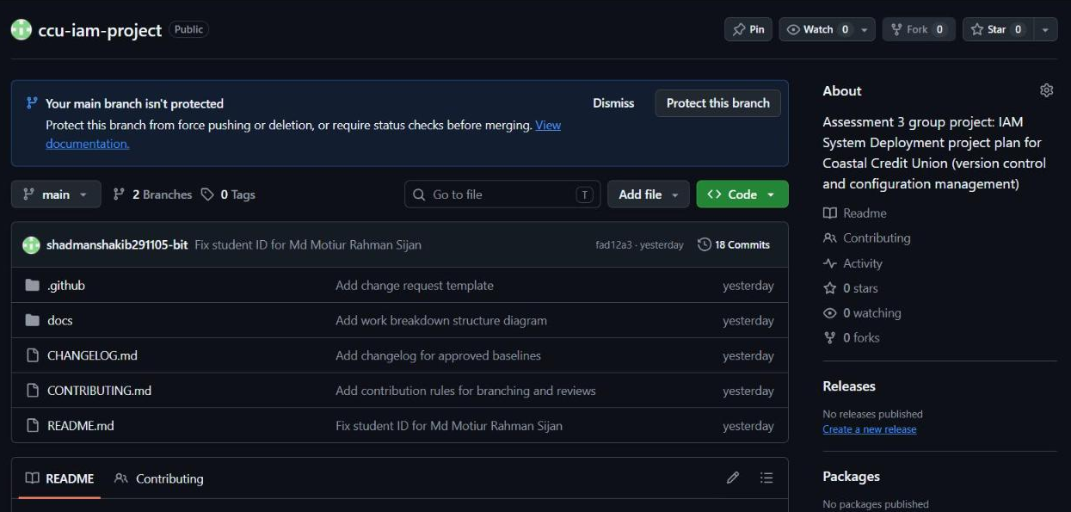
Figure 5: Repository home page showing the folder structure and README
Each change is saved as a commit with a short message, giving a full version history (Section 11.4).
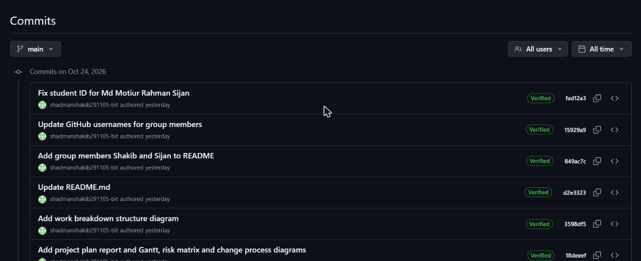
Figure 6: Commit history of the main branch
Risks, issues and change requests are logged as GitHub issues using labels and templates (Sections 6, 7 and 8).
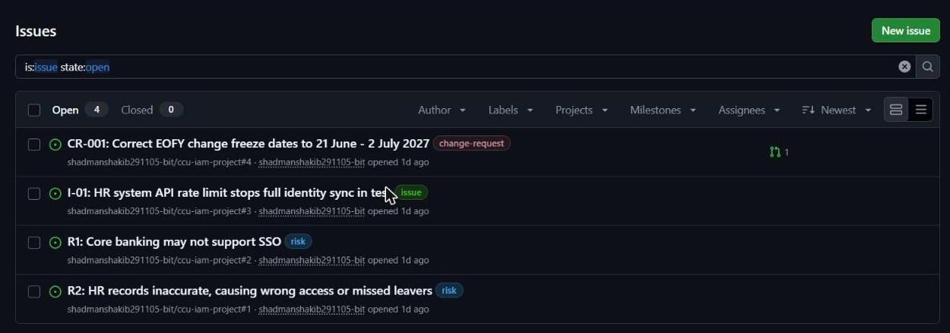
Figure 7: Issue log with risk, issue and change-request labels
Changes are made on a separate branch and submitted as a pull request for review before merging (Sections 8 and 11.4).
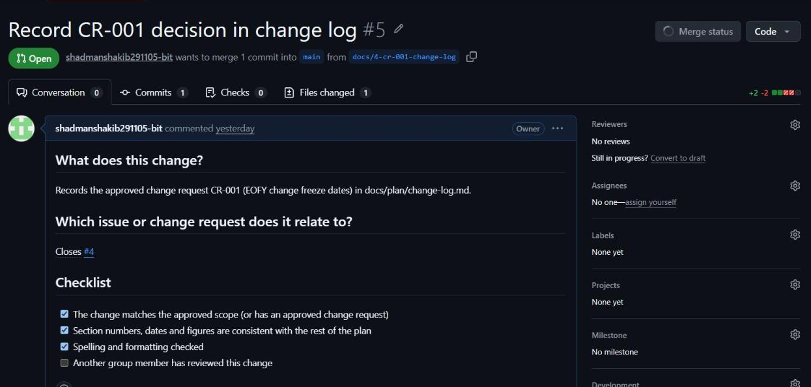
Figure 8: Pull request #5 linking change request CR-001 to the change log update
Work packages from the WBS are tracked in To do, In Progress and Done columns (Section 11.5).
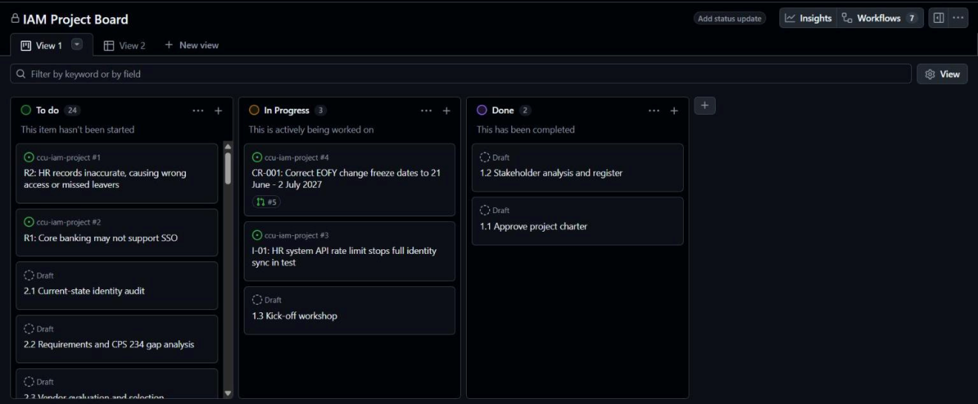
Figure 9: IAM Project Board (GitHub Projects) showing work package status
Group members are added as collaborators so each member can contribute from their own account.
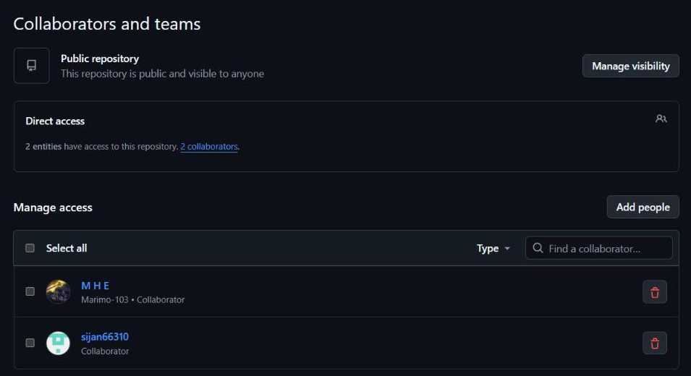
Figure 10: Repository collaborators (group members with access)

